**SCIENCE DEPARTMENT**

**YEAR 11 HUMAN BIOLOGY**

**2010**

**CELLS, METABOLISM AND DNA**

|  |  |  |  |  |
| --- | --- | --- | --- | --- |
| **Student Name:** |  |  | **Class:** |  |

**SECTION A: MULTIPLE CHOICE (25 marks)**

**Answer ALL questions in this section by choosing the most correct alternative and putting a cross through the corresponding letter on the separate Multiple Choice Answer Sheet provided.**

1. The organelles in a cell which are responsible respectively for protein synthesis, energy production and secretion are:

(a) ribosomes, Golgi bodies, endoplasmic reticulum.

(b) Golgi bodies, ribosomes, mitochondria.

(c) mitochondria, ribosomes, endoplasmic reticulum.

(d) mitochondria, nucleus, cell membrane.

(e) ribosomes, mitochondria and Golgi bodies.

2. When the nucleus is removed from a cell and replaced within two days, the cell survives. If it is not replaced, the cell dies. Which of the following statements best explains these results?

(a) The nucleus is the major site of energy production in the cell.

(b) The nucleus contains DNA which controls cell division.

(c) The nucleus supplies information which is necessary for maintaining chemical processes.

(d) The nucleus is the major site of protein synthesis in the cell.

3. There are more mitochondria in muscle cells than in any other type of cell. This suggests muscle cells:

(a) are larger than other cells.

(b) lack enzymes.

(c) use more ATP.

(d) have long fibres.

4. The diagram below illustrates some of the many events in mitosis.

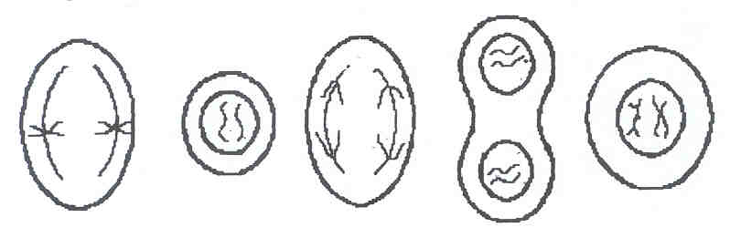

**I II III IV V**

The correct sequence of these events is as follows:

(a) II, V, I, III, IV.

(b) IV, III, V, I, II.

(c) I, V, III, II, IV.

(d) II, I, V, III, IV.

(e) V, I, III, IV, II.

5. The two strands of a chromosome which go to opposite poles of the cells during mitosis are called:

(a) kinetochromes.

(b) chromatids.

(c) spindle fibres.

(d) centrosomes

6. Which of the following is a feature of mitosis?

(a) Metaphase is characterised by division and migration of the centrioles.

(b) Interphase is characterised by the appearance of chromosomes in the nucleus.

(c) Prophase is characterised by separation of the centromeres.

(d) Telophase is characterised by the reappearance of the nuclear membrane.

7. The substance in the nucleus of a cell which determines the characteristics of the cell is:

(a) ATP.

(b) ADP.

(c) RNA.

(d) DNA.

8. Mitotic division of a cell containing a diploid (2N) nucleus normally produces:

(a) 2 cells, each with an N nucleus.

(b) 2 cells, each with a 2N nucleus.

(c) 4 cells, each with an N nucleus.

(d) 4 cells, each with a 2N nucleus.

9. When a muscle becomes fatigued, which of the following would best represent its condition? There is:

(a) little or no ATP, little glycogen and much lactic acid.

(b) much lactic acid, much glycogen and little ATP.

(c) little lactic acid, little ATP and much glycogen.

(d) no glycogen, little lactic acid and much ATP.

10. In the diagram of a chromosome from a cell in late prophase, to what structure is the arrow pointing?

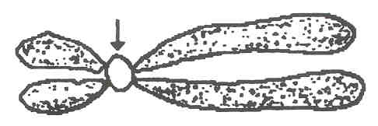

(a) Centriole.

(b) Chromatid.

(c) Spindle.

(d) Centromere.

11. Which of the following is the site for aerobic respiration?

(a) Nucleus.

(b) Cytoplasm.

(c) Mitochondria.

(d) Ribosomes.

12. During the process of mitosis there are a number of clearly visible stages. During which stage do chromosomes line up of the equator of the cell?

(a) Interphase.

(b) Prophase.

(c) Metaphase.

(d) Anaphase.

13 ATP is essential to every living cell because it:

(a) Stores energy released during the breakdown of ADP.

(b) Speeds up the digestion of food.

(c) Stores energy in a form that is readily available.

(d) Reacts with energy from glucose to form ADP.

14. An oxygen debt occurs:

(a) During aerobic exercise.

(b) Following aerobic exercise.

(c) During anaerobic exercise.

(d) Following anaerobic exercise.

15. Where X→ADP + Y, compounds X and Y respectively are:

(a) Phosphate; ATP

(b) Phosphorous; ATP

(c) ATP; Phosphorous

(d) ATP; Phosphate

16. A by-product of anaerobic respiration in humans is:

(a) fatty acid.

(b) nucleic acid.

(c) lactic acid.

(d) amino acid.

17. The main function of enzymes in living cells is:

(a) To convert food into soluble form

(b) To alter the rate of chemical reactions

(c) To build up complex structures from simple, inorganic substances

(d) To decompose complex structures into simple, inorganic substances

18. The diagram below shows some of the stages of mitosis:

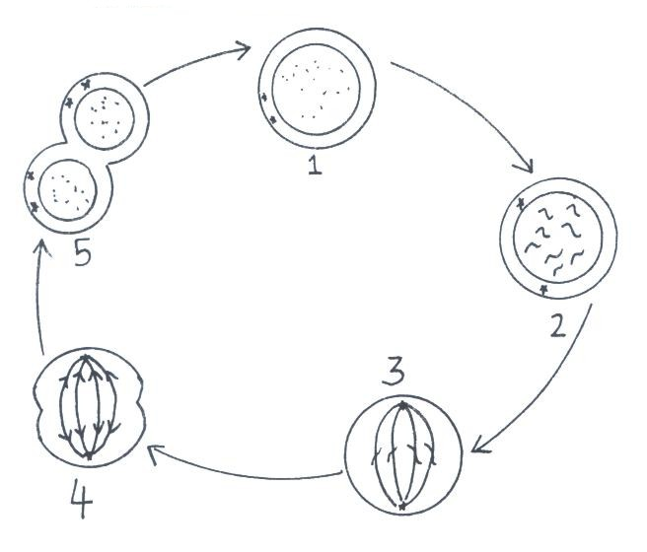

The amount of DNA present is doubled during stage:

(a) 1

(b) 2

(c) 4

(d) 5

19. Carbohydrates are stored in the liver and muscles as:

(a) glucose.

(b) glycogen.

(c) glucagon.

(d) glycosides.

20. Maltose is an example of a:

(a) Lipid

(b) Polysaccharide

(c) Disaccharide

(d) Monosaccharide

21. Fats contain the elements:

(a) Carbon, hydrogen and nitrogen

(b) Hydrogen and oxygen

(c) Carbon, hydrogen and oxygen

(d) Fatty acids and glycerol.

22. Which one of the following reactions is catalysed by lipase?

(a) Starch to maltose and glucose

(b) Fats to fatty acids and glycerol

(c) Polypeptides to amino acids

(d) Proteins to proteases.

23. The basic units composing proteins are:

(a) fatty acids

(b) amino acids

(c) monosaccharides

(d) glycerol

24. Vitamins function as:

(a) raw materials for bones and teeth

(b) sources of heat and energy

(c) mineral salts regulating the cellular functions

(d) organic substances necessary for normal metabolic functioning

25. A model for enzyme action can be given as follows. 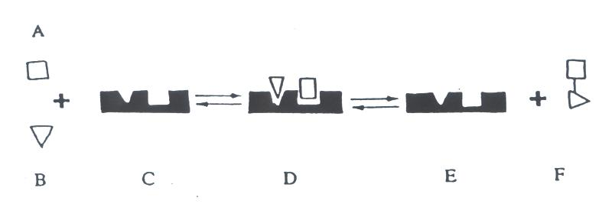

In the diagram above:

(a) substance C is required in large amounts for the enzyme action to occur

(b) substance E is a protein

(c) the rate of the reaction represented in the diagram will be unaffected by changes in temperature

(d) substance C could also take part in another reaction involving two other substances X and Y (not shown)

**PART B: SHORT ANSWER (45 marks)**

1. (a) Write the equation for the complete oxidation of glucose in aerobic respiration.

[3 marks]

|  |
| --- |
|  |

(b) Aerobic and anaerobic respiration both involve **glycolysis**.

(i) What is the initial reactant? [1 mark]

|  |
| --- |
|  |

(ii) What is the final product? [1 mark]

|  |
| --- |
|  |

(iii) How many ATP molecules are produced in glycolysis? [1 mark]

|  |
| --- |
|  |

(c) What is the ultimate product of anaerobic respiration? [1 mark]

|  |
| --- |
|  |

(d) How does accumulation of the product of (c) affect muscles? [2 marks]

|  |
| --- |
|  |

(e) Describe 4 ways that cells may use energy. [4 marks]

|  |  |
| --- | --- |
| 1 |  |
| 2 |  |
| 3 |  |
| 4 |  |

2. Refer to the diagram below.

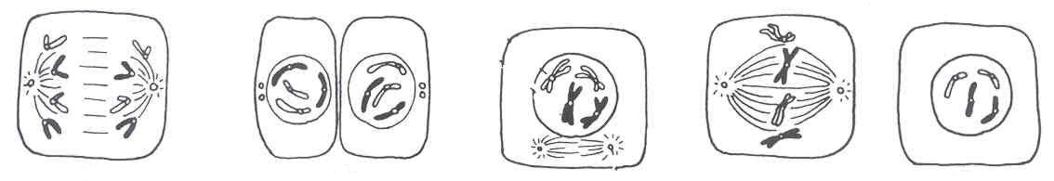

**1 2 3 4 5**

(a) Write the sequence of cells undergoing mitosis in the correct order. Assume 5 is the start. Numbers only required. [1 marks]

|  |
| --- |
|  |

(b) Describe **cytokinesis.**

[2 marks]

|  |
| --- |
|  |

3. Using the graph answer the following questions.

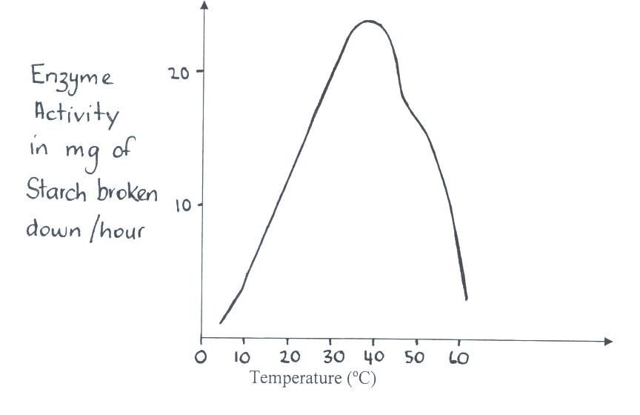

1. What is the optimum temperature for the activity of this enzyme? [1 mark]

|  |
| --- |
|  |

1. Why does the activity drop rapidly at temperatures above 45oC? [2 marks]

|  |
| --- |
|  |

|  |
| --- |
|  |

1. Describe 3 factors, other than temperature which affect the activity of an enzyme.

[3 marks]

|  |  |
| --- | --- |
| 1 |  |
| 2 |  |
| 3 |  |

1. Describe the structure and function of the ‘active site’ of an enzyme.

[2 marks]

|  |
| --- |
|  |

|  |
| --- |
|  |

|  |
| --- |
|  |

|  |
| --- |
|  |

|  |
| --- |
|  |

|  |
| --- |
|  |

|  |
| --- |
|  |

4. Complete the table below: [6 marks]

|  |  |  |
| --- | --- | --- |
|  | **ELEMENTS MADE OF** | **FUNCTION** |
| carbohydrates |  |  |
| lipids |  |  |
| RNA |  |  |

5. Write the appropriate term for the following phrases. [6 marks]

|  |  |
| --- | --- |
| The term used to describe the sum total of all the chemical processes which occur in the body |  |
| The type of chemical reaction in which large molecules are broken into small ones. |  |
| When cells divide to produce sex cells or gametes. |  |
| Respiration which occurs in the absence of oxygen. |  |
| A unit containing a phosphate group, a sugar and a nitrogen base is called a...... |  |
| DNA making an exact copy of itself is called. |  |

6. Suppose that part of a DNA molecule has the following sequence of bases:

**CCT GCG CAT ATT AGT AGA**

1. What would be the sequence of bases on the complementary strand of the DNA molecule. [3 marks]

__________________________________________________________________

1. What would be the sequence of bases on the complementary strand of the messenger RNA molecule. [3 marks]

__________________________________________________________________

7. List 3 differences between mitosis and meiosis in the human. [3 marks]

|  |  |  |
| --- | --- | --- |
|  | **MITOSIS** | **MEIOSIS** |
| 1 |  |  |
| 2 |  |  |
| 3 |  |  |